Update or Install Rsync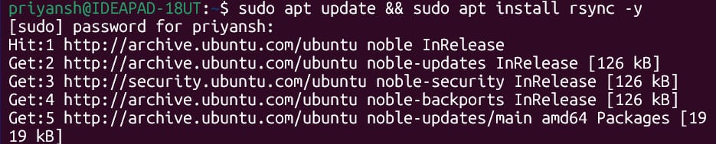
Basic rsync backup -
-a - to archive
-v – verbose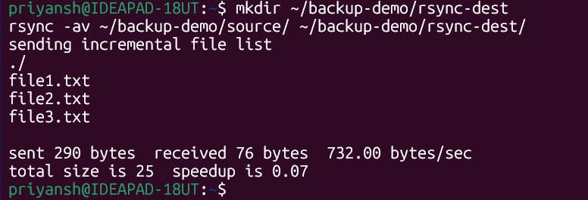
Incremental Backup (only changed files) 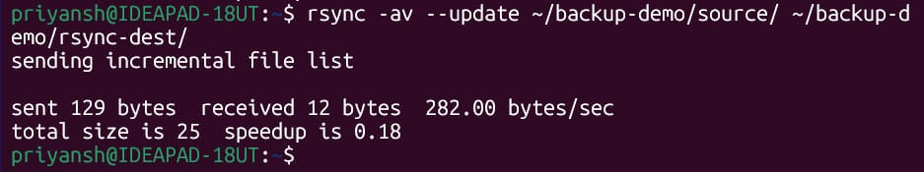
Rsync with –backup to keep old version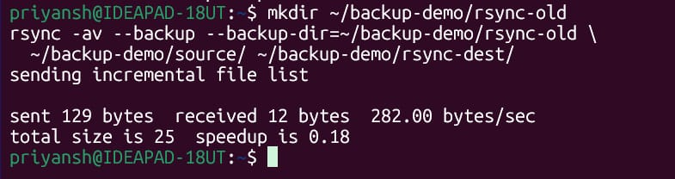
Stimulate rdiff-backup style – using rsync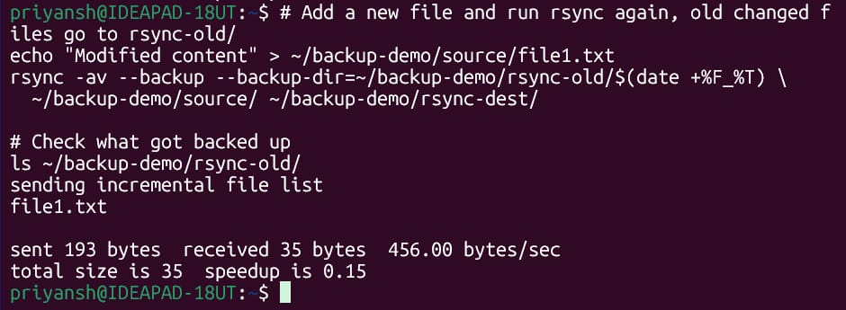
Schedule with cron command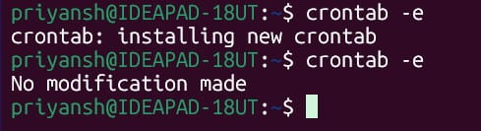
Crontab - script